2024 KINGBOROUGH BUSINESS AWARDS
OFFICIAL ENTRY FORM (FREE ENTRY)

Name
Business Name
Business Location
Phone Number/s
Website
Facebook / Snapchat / Instagram / WhatsApp etc.
Email
Date business commenced operation
Chosen Award Category
(see last page of entry form)
Entrants’ declaration | In submitting this entry, I acknowledge that the judging panel’s decision is final and will not be subject to any challenge. I agree that the material in this document is correct at the time of submission.  Signed: _________________________

Entry Checklist
- Closing date is 5pm on Friday the 14th of June 2024. No entries will be accepted after this date.
- Official Entry form completed and signed.
- Submissions must answer all relevant questions, in the template provided (this document).
- Please include supporting materials such as brochures and/or samples of your product, business cards etc.
- Entrants are encouraged to be as creative as they desire within the context of the submission of detailed questions e.g. pictures, references, anything that will help the judges understand your business better.
- Email your submission to: kerry@khbec.com.au

Judging

The judging panel will consist of independent industry experts. Judges will grade submissions using predetermined criteria for rating responses against the requirements outlined in the category descriptions. In the event of extenuating circumstances KHBEC reserves the right to veto/overall the judge’s decision if it is determined to be improper or otherwise damaging to the reputation of the awards, the Kingborough area or any of the participants. All private and confidential details of yours will remain with us and will not be disclosed to anyone without your consent.

SUBMISSION DETAILS

History
Please provide a brief history of your business.

Product / Service
Provide a brief overview of your products &/or services

Customer Service
Explain why customers want to deal with your business.

Include testimonials from your customers (if applicable).

Marketing
Explain what marketing activities you have implemented and what has worked for you.

Sales & Revenue Growth
Please describe your sales and revenue growth over the last 2 years. E.g. sales grew by 25% or profit increased by 30%.

Personnel (if applicable)
How many people are employed in your business?

What processes do you have in place to recognize and reward employees?

What ways are staff encouraged to contribute to the achievement of your business’ goals and objectives?

Business Achievements
List three key elements that contribute to your business’ success.
Why have these elements been important to your business?

Business Challenges
Please explain any challenges you have had to overcome in order to achieve these results.

How did you do this?

Is there anything else you would like to tell us?

To download the entry form, scan the QR code below or go to https://www.khbec.com.au/2024-kingborough-business-awards/
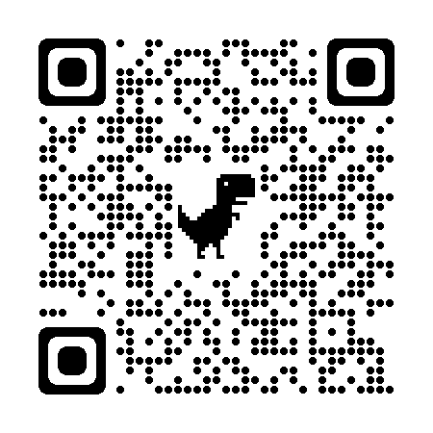

KINGBOROUGH BUSINESS AWARDS

Why enter?

Entering the Business Awards provides your business with an unparalleled opportunity to:

- Gain recognition at a local, regional and state level.
- Get free advertising and recognition.
- Raise the profile and showcase your business.
- Build a reputation for excellence inside and outside your industry.
- Benchmark your business year on year and against other businesses in your local area and industry.
- Improve employee engagement by involving your employees in the entry process.
- Boost staff morale through the recounting of successes and wins in your business.
- Entry into the business awards is FREE.

CATEGORIES

- Online Presence Award (e.g. via website or social media)
- Manufacturing, Construction, Export & Trade Services (e.g. electricians, plumbers etc.)
- Professional Services (real estate, solicitors, accounting, surveyors etc.)
- Retail and Retail Services (including hair & beauty)
- Designers, Creators and Makers
- Food & Hospitality (restaurants, cafes, mobile vans)
- New Business Start Up (less than 2 years old)
- Tourism, Accommodation, Events and Entertainment
- Brewers, Wineries & Distillers
- KHBEC Business of the Year (must be a financial member of KHBEC to enter)

All categories include those businesses that are operated from home

Eligibility Criteria - Open to all businesses registered or operating in the Kingborough Local Government Area

The 2024 Kingborough Business Awards are proudly brought to you by the Kingborough and Huon Business Enterprise Centre – giving guidance and support to businesses or business intenders since 1999.

www.khbec.com.au Phone: 6229 9200

